1. **Agenda**:
   1. How WireMock receives HTTP Request?
   2. How it matches with the stubs?
   3. How it responds?
2. First question: Who spins the WireMock Server?
   1. WireMock is HTTP Server.
   2. 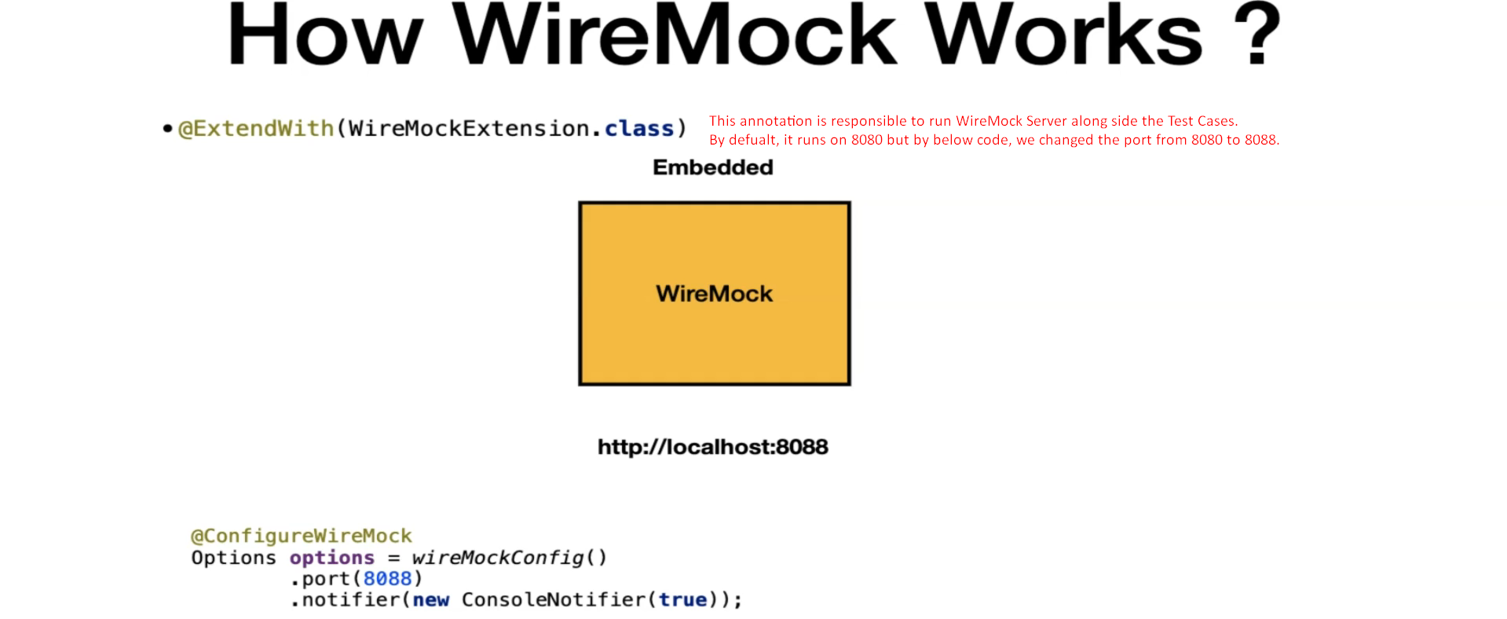
3. **Question**: How stubs are added to WireMock Server?
   1. 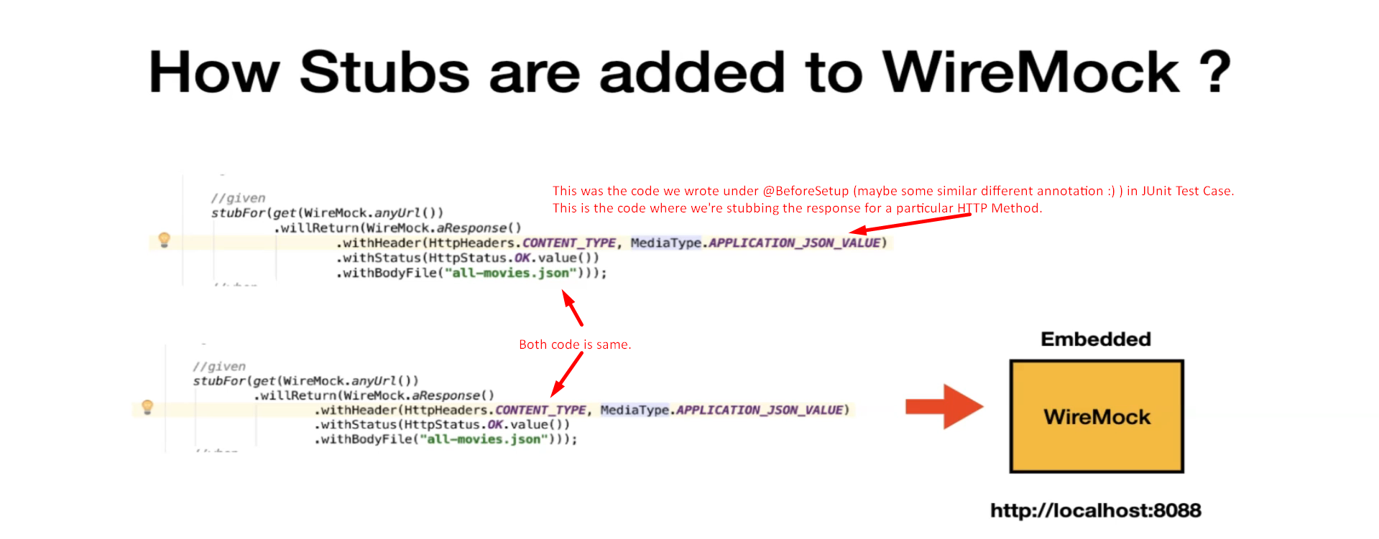
4. Let’s put both the piece together to get a clear picture.  
   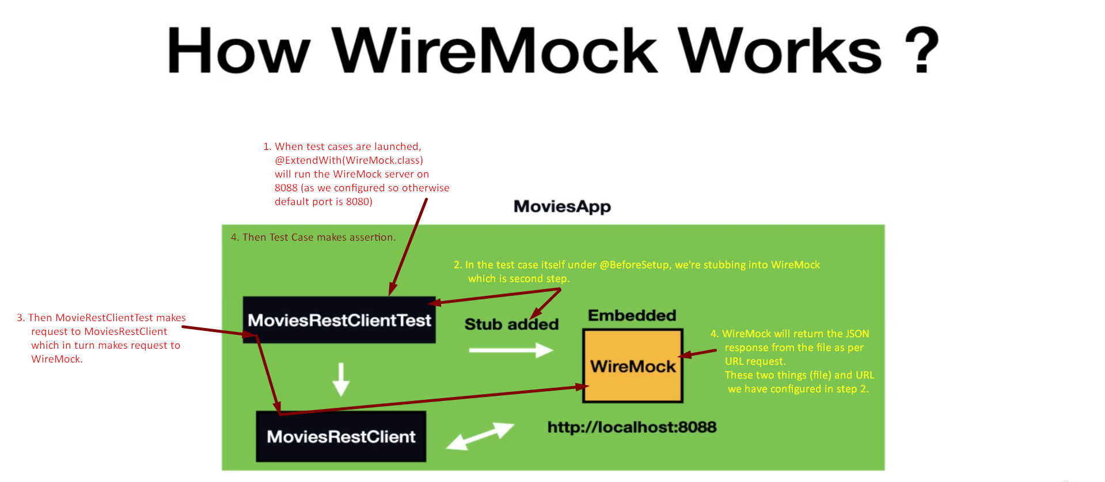
5. **Question**: How does WireMock match the stub?  
   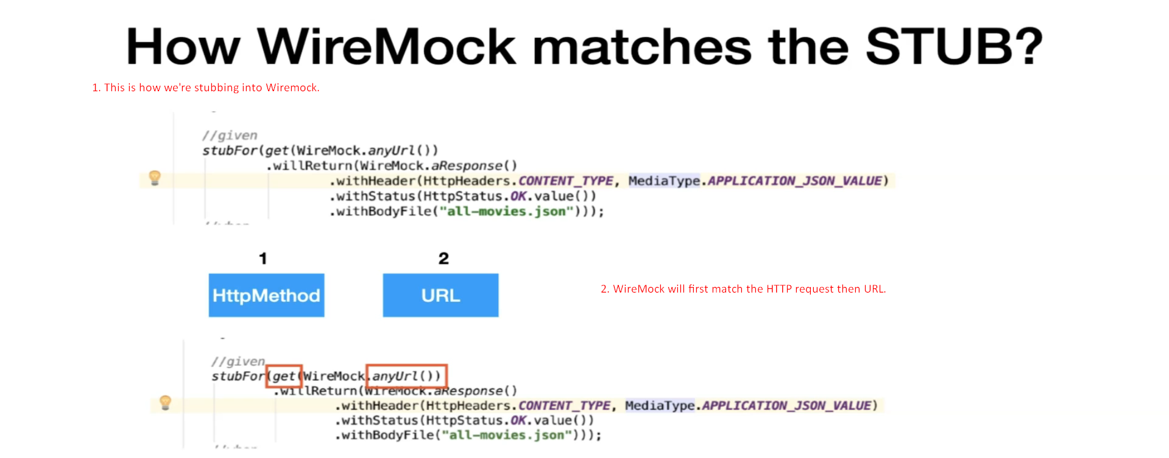
6. 